**CS5551 Advanced Software Engineering**

**Speech Helper - Iteration IV**

**Due Date: May. 6 (M) 2013, Midnight**

Team Members:

Geetalakshmi Javvadi

Jinal Patel

Supraja Raghavan

**Detail Design of Services - Iteration 4:**

For the Iteration IV, we included our application on the android using phonegap, which is an open source for the integrating media player with HTML5 web pages that makes the authentic user to access the words list along with their audio files.

**Words list Web Service:**

For this Iteration we will integrate the Web services and html5 pages to the media player in the android that the user will use after he / she login to the application and selecting the group. This application homepage will have the details of the user’s group and account management information. From this the user can then select their respective group and check the list of words that will be shown to them according to their user group type.

In this iteration we will design, implement and test the application required for our users to choose their wordlist based on the group for our application. We will also use the same android simulator to test the proper working of our application.

**Web Service – Accent Mobile Application:**

After a user has registered and logged in to the mobile application, the user can access his/her group. This group contains the list of words for which the user would like to learn the accent for. When the user logs in subsequently they can access a list of most recently used words. When the user selects a word, the accent audio next to the word can be played as many times as the user wants. Thus the user can listen to the words as many times as wanted to practice the correct accent of the word. The user can also manage their account with this application. The class diagram, sequence diagram and the service specification are as shown below.

For this Iteration we have recreated the user Registration, Login and have created the web service that the user can access after logging into the application. The web service that we created is used to allow the user to select his/her desired group. The users of our application need to specify a group to which he/she would have access to. The users can select from various groups such as Chinese, Japanese, and Indian. The user needs to provide his/her username and the group they would like to select. Once the group is selected, the user is able to access a list of words that are there in that group. We have categorized the words in different based on the difficulty faced by the people of that native language in correcting the accent.

For this iteration we have also tried to access the application and word list access from our Android device. We have designed and implemented the code to access the web service through our android interface. We have integrated the android access of the media player with HTML5 using phonegap to this iteration. The class and sequence diagram of our application are as shown below.

**Service Specifications for Accent Mobile Application:**

**Manage Account**

* Description: Update account information and group
* Input: Account information
* Output: Confirmation
* Precondition: User is logged in successfully
* Post condition: Account information is updated
* Actors involved: User, Group, DBInterface, WordList
* Object involved: User

**WordList**

* Description: Access the word list
* Input: username
* Output: Wordlist
* Precondition: User authenticated and has group selected
* Post condition: Wordlist for the user
* Actors involved: User
* Object involved: WordList, RecentWordList, GroupWordList, User



**Sequence Diagram:**



**WSDL Service Specification:**

<?xml version="1.0" encoding="utf-8" ?>

[**-**](http://localhost:49783/SpeechHelperLogin/GroupSelection.asmx?WSDL)<wsdl:definitions xmlns:soap="**http://schemas.xmlsoap.org/wsdl/soap/**" xmlns:tm="**http://microsoft.com/wsdl/mime/textMatching/**" xmlns:soapenc="**http://schemas.xmlsoap.org/soap/encoding/**" xmlns:mime="**http://schemas.xmlsoap.org/wsdl/mime/**" xmlns:tns="**http://tempuri.org/**" xmlns:s="**http://www.w3.org/2001/XMLSchema**" xmlns:soap12="**http://schemas.xmlsoap.org/wsdl/soap12/**" xmlns:http="**http://schemas.xmlsoap.org/wsdl/http/**" targetNamespace="**http://tempuri.org/**" xmlns:wsdl="**http://schemas.xmlsoap.org/wsdl/**">

[**-**](http://localhost:49783/SpeechHelperLogin/GroupSelection.asmx?WSDL)<wsdl:types>

[**-**](http://localhost:49783/SpeechHelperLogin/GroupSelection.asmx?WSDL)<s:schema elementFormDefault="**qualified**" targetNamespace="**http://tempuri.org/**">

[**-**](http://localhost:49783/SpeechHelperLogin/GroupSelection.asmx?WSDL)<s:element name="**SHGroupSelection**">

[**-**](http://localhost:49783/SpeechHelperLogin/GroupSelection.asmx?WSDL)<s:complexType>

[**-**](http://localhost:49783/SpeechHelperLogin/GroupSelection.asmx?WSDL)<s:sequence>

<s:elementminOccurs="**0**" maxOccurs="**1**" name="**Username**" type="**s:string**" />

<s:elementminOccurs="**0**" maxOccurs="**1**" name="**Groupname**" type="**s:string**" />

</s:sequence>

</s:complexType>

</s:element>

[**-**](http://localhost:49783/SpeechHelperLogin/GroupSelection.asmx?WSDL)<s:element name="**SHGroupSelectionResponse**">

[**-**](http://localhost:49783/SpeechHelperLogin/GroupSelection.asmx?WSDL)<s:complexType>

[**-**](http://localhost:49783/SpeechHelperLogin/GroupSelection.asmx?WSDL)<s:sequence>

<s:elementminOccurs="**0**" maxOccurs="**1**" name="**SHGroupSelectionResult**" type="**s:string**" />

</s:sequence>

</s:complexType>

</s:element>

</s:schema>

</wsdl:types>

[**-**](http://localhost:49783/SpeechHelperLogin/GroupSelection.asmx?WSDL)<wsdl:message name="**SHGroupSelectionSoapIn**">

<wsdl:partname="**parameters**" element="**tns:SHGroupSelection**" />

</wsdl:message>

[**-**](http://localhost:49783/SpeechHelperLogin/GroupSelection.asmx?WSDL)<wsdl:message name="**SHGroupSelectionSoapOut**">

<wsdl:partname="**parameters**" element="**tns:SHGroupSelectionResponse**" />

</wsdl:message>

[**-**](http://localhost:49783/SpeechHelperLogin/GroupSelection.asmx?WSDL)<wsdl:portType name="**GroupSelectionSoap**">

[**-**](http://localhost:49783/SpeechHelperLogin/GroupSelection.asmx?WSDL)<wsdl:operation name="**SHGroupSelection**">

<wsdl:inputmessage="**tns:SHGroupSelectionSoapIn**" />

<wsdl:outputmessage="**tns:SHGroupSelectionSoapOut**" />

</wsdl:operation>

</wsdl:portType>

[**-**](http://localhost:49783/SpeechHelperLogin/GroupSelection.asmx?WSDL)<wsdl:binding name="**GroupSelectionSoap**" type="**tns:GroupSelectionSoap**">

<soap:bindingtransport="**http://schemas.xmlsoap.org/soap/http**" />

[**-**](http://localhost:49783/SpeechHelperLogin/GroupSelection.asmx?WSDL)<wsdl:operation name="**SHGroupSelection**">

<soap:operationsoapAction="**http://tempuri.org/SHGroupSelection**" style="**document**" />

[**-**](http://localhost:49783/SpeechHelperLogin/GroupSelection.asmx?WSDL)<wsdl:input>

<soap:bodyuse="**literal**" />

</wsdl:input>

[**-**](http://localhost:49783/SpeechHelperLogin/GroupSelection.asmx?WSDL)<wsdl:output>

<soap:bodyuse="**literal**" />

</wsdl:output>

</wsdl:operation>

</wsdl:binding>

[**-**](http://localhost:49783/SpeechHelperLogin/GroupSelection.asmx?WSDL)<wsdl:binding name="**GroupSelectionSoap12**" type="**tns:GroupSelectionSoap**">

<soap12:bindingtransport="**http://schemas.xmlsoap.org/soap/http**" />

[**-**](http://localhost:49783/SpeechHelperLogin/GroupSelection.asmx?WSDL)<wsdl:operation name="**SHGroupSelection**">

<soap12:operationsoapAction="**http://tempuri.org/SHGroupSelection**" style="**document**" />

[**-**](http://localhost:49783/SpeechHelperLogin/GroupSelection.asmx?WSDL)<wsdl:input>

<soap12:bodyuse="**literal**" />

</wsdl:input>

[**-**](http://localhost:49783/SpeechHelperLogin/GroupSelection.asmx?WSDL)<wsdl:output>

<soap12:bodyuse="**literal**" />

</wsdl:output>

</wsdl:operation>

</wsdl:binding>

[**-**](http://localhost:49783/SpeechHelperLogin/GroupSelection.asmx?WSDL)<wsdl:service name="**GroupSelection**">

[**-**](http://localhost:49783/SpeechHelperLogin/GroupSelection.asmx?WSDL)<wsdl:port name="**GroupSelectionSoap**" binding="**tns:GroupSelectionSoap**">

<soap:addresslocation="**http://localhost:49783/SpeechHelperLogin/GroupSelection.asmx**" />

</wsdl:port>

[**-**](http://localhost:49783/SpeechHelperLogin/GroupSelection.asmx?WSDL)<wsdl:port name="**GroupSelectionSoap12**" binding="**tns:GroupSelectionSoap12**">

<soap12:addresslocation="**http://localhost:49783/SpeechHelperLogin/GroupSelection.asmx**" />

</wsdl:port>

</wsdl:service>

</wsdl:definitions>

**Implementation**

We have created the required database tables and have implemented the web service for user Registration and Login. We have designed and implemented the application in the android for word list access based on the group selection. For this iteration we have used the web page using HTML5 that allows a new user to select his/her group for the Speech Helper software and access the words list of that particular group. We have implemented the application to allow users to select the group and the words list. The accessed words list is also played and listened as many times as required by the user. So that whenever user wants to check the pronunciation can practice other words or check the same. We have implemented and tested the code for the web service using android simulator.

**Project Video:**

For this iteration, we have created a video of our project. The youtube URL of the project video is given by <http://www.youtube.com/watch?v=pAO_fN5Ry9E&feature=youtube_gdata>.

The Video consists of the details of our project, the video discusses about our project, its objectives and discusses about our project architecture and implementation. We also demonstrate the web services and the android application in the video.

**The various Screen Shots for the HTML page and the web services are attached below:**

**Screen shot of the HTML Page:**

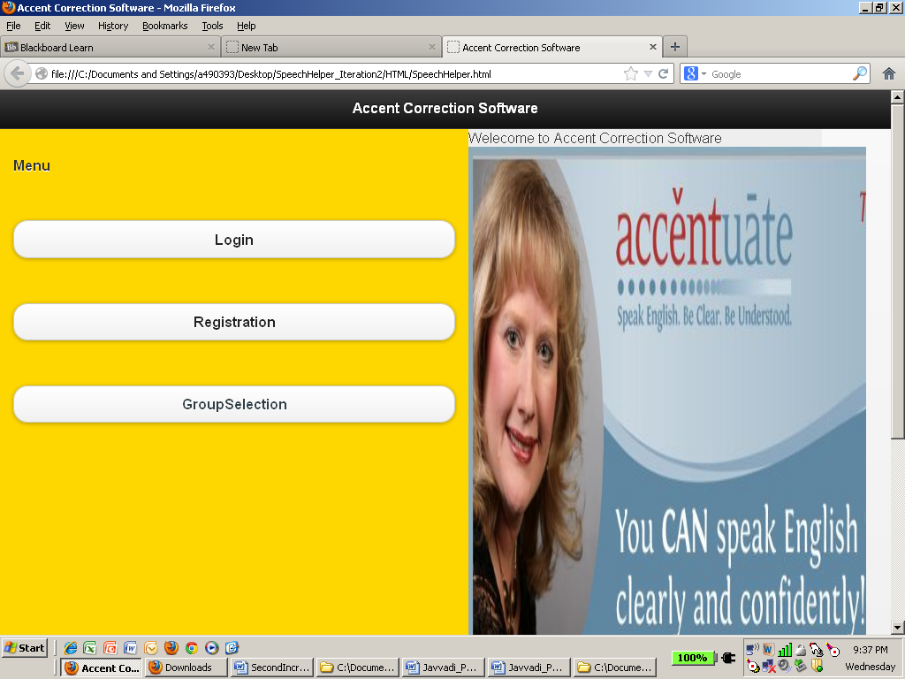

**Screen Shot for Group Selection:**

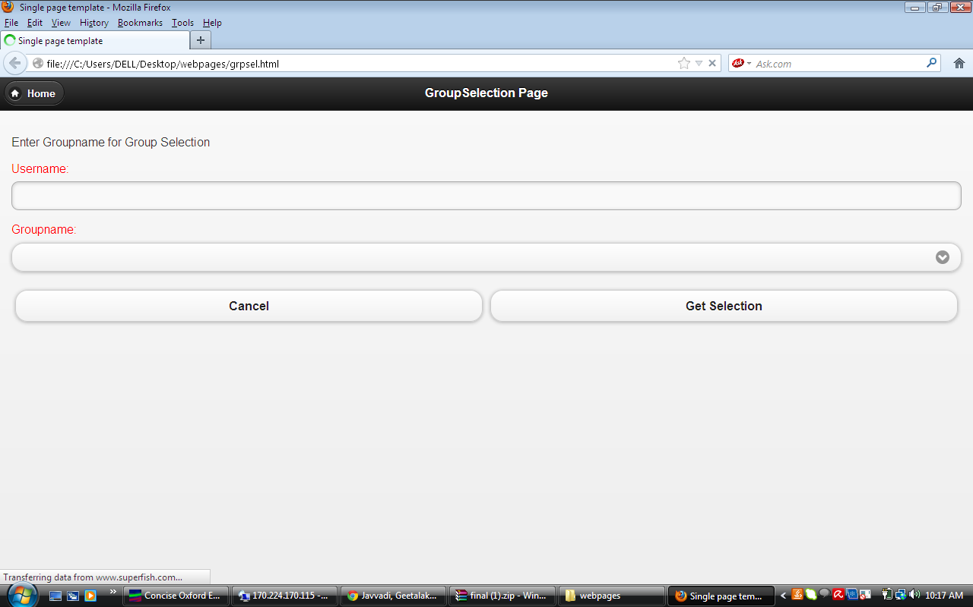

**Calling the Web Service through the android application:**

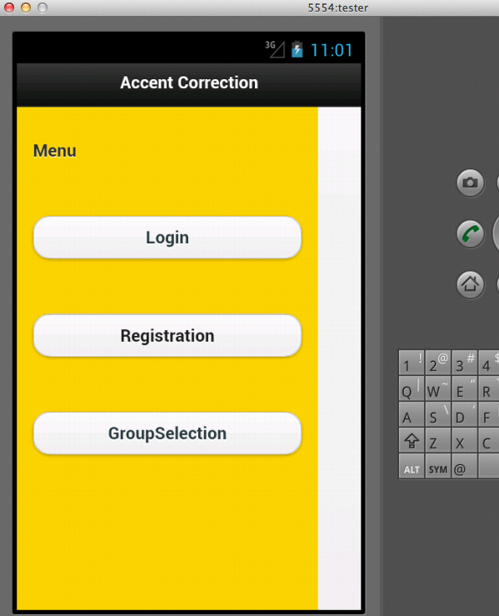

**Screen Shot of the Group Selection:**

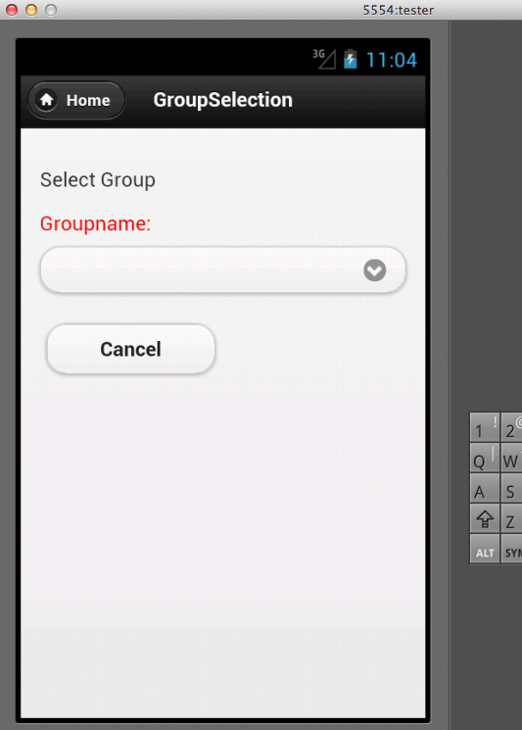

**Screen Shot of the Group Selection using Android Simulator:**

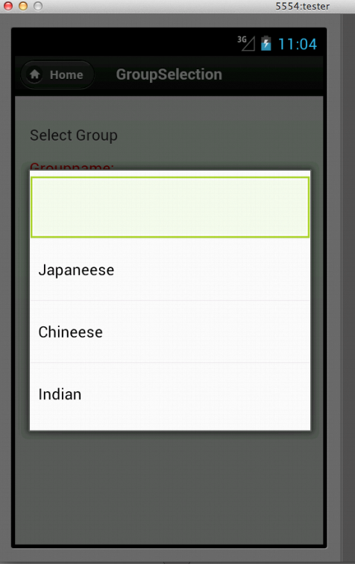

**Screen Shot of the Android Application, to play the word list:**

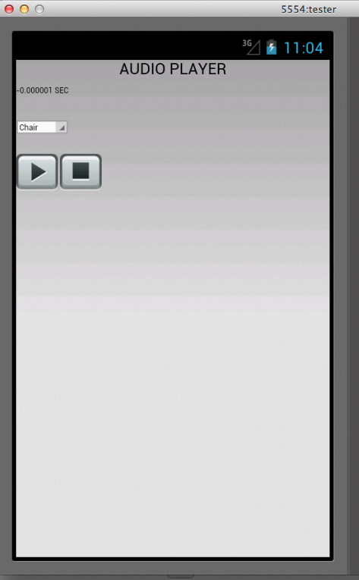

**Project Iteration IV implementation Status:**

Project Completed - Work Completed:

Creating, Implementing and testing the web services and integrating the services with Android and running the pronunciation correction application:

Geeta: 12 hrs.

Jinal: 12 hrs and

Supraja: 12 hrs.

**Internet Access:**

* 1. GitHub (URL):

We use GitHub for development version control. We have a GitHub account for the same. The URL is: <https://github.com/ASE-Javvadi-Patel-Raghavan/PronunciationHelper.git>

* 1. The Youtube URL for the Project Video is as follows

<http://www.youtube.com/watch?v=pAO_fN5Ry9E&feature=youtube_gdata>

* 1. Project Website URL is <http://170.224.170.115/FileUploadDwnload/fileUD.aspx>